2.1.1 Cell Structure End of Topic Test

NAME __________________________________

Qu. | Topic | Marks  available | Predicted  mark | Actual mark
 | Section A - multichoice | 5
 | Section B - Definitions and use of microscope | 11
1 | Microscopy and cell structures | 11
2 | Cell structures and function; microscopy | 8
3 | Cell structures and function | 10
 | Total | 45
Reflection:

Spelling, punctuation or grammar | Maths, data analysis or experimental techniques | Application  of  knowledge | Not Reading question carefully | Clarity and precision of answer | Knowledge not revised/  understood | Statements per mark

Section A – multiple choice

1) What is the advantage of using a light microscope to observe cells?
- You can observe cells at a maximum magnification of ×500 000.
- You can observe living cells.
- You can observe the three-dimensional surface of cells.
- You can observe organelles in detail.

Choose 1 answer ___ [1]

2) Why is staining used in the preparation of microscope slides? Which of the following statements is/are true?

- To observe specific organelles.
- To preserve cells.
- To differentiate between different types of cell.
- To distinguish between different tissues.

- Only statement 2 is true.
- Statements 1, 3, and 4 are true.
- Only statements 1 and 3 are true.
- Only statements 3 and 4 are true.

Your answer ___ [1]

3) Name the ways in which prokaryotic cells are different to eukaryotic cells.
- Prokaryotic cells do not have a nucleus or membrane-bound organelles.
- Prokaryotic cells do not have membrane-bound organelles or a cell wall.
- Prokaryotic cells do not have membrane-bound organelles or ribosomes.
- Prokaryotic cells do not have a nucleus or ribosomes.

Choose 1 answer ___ [1]

4)
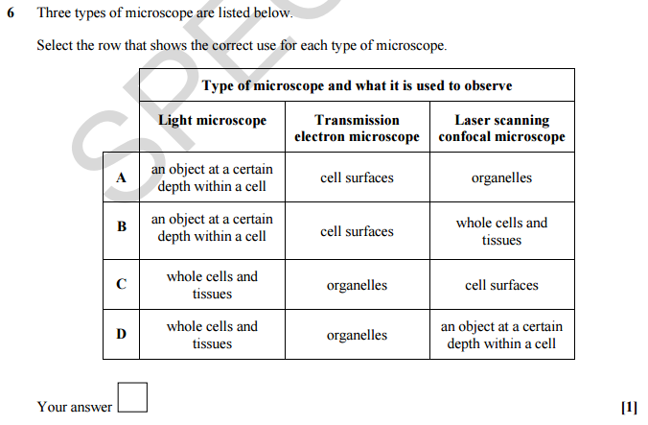

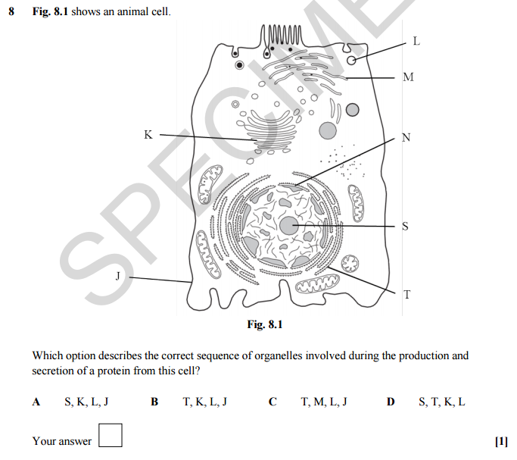
5)

[Total: 5]

Section B – short answer questions

- State the correct term for each of the following definitions.
  - A structure within cells consisting of microtubules and microfilaments.
[1]
  - A graduated measuring scale placed on the microscope stage.
[1]
  - The two parts of a light microscope that magnify the specimen.

[2]
  - The dark staining region of a cell where ribosomes are made.
[1]
  - The detailed structure of cells visible only with an electron microscope.
[1]
[Total: 6]

- A student used the following procedure to view her own cheek epithelium cells. She:
1. rubbed a cotton wool bud inside her cheek
2. rubbed this onto a clean microscope slide
3. added three drops of methylene blue solution
4. angled a cover slip over this and lowered it gently
5. set the microscope to its lowest magnification
6. placed the slide on the stage
7. looked through the eyepiece to search for cells.

  - Explain why:
    - methylene blue was added
[1]
    - the cover slip was lowered gently
[1]
    - the microscope was set to its lowest magnification.
[1]
b The student had eaten cereal and not cleaned her teeth before making her cheek cell slide. Plaque bacteria and pieces of fibrous plant material were visible on the slide. Suggest how the bacterial and plant cells could be distinguished from the cheek cells.

[2]
[Total: 5]

Section C – long answer questions

Question: 1

The use of microscopy has greatly enhanced our knowledge of cell structure.
(a) Explain the difference between magnification and resolution.

_____________________________________________________________________________________________________

_____________________________________________________________________________________________________

_____________________________________________________________________________________________________

[2]

(b) Fig. 4.1 is an electron micrograph showing part of a nucleus.

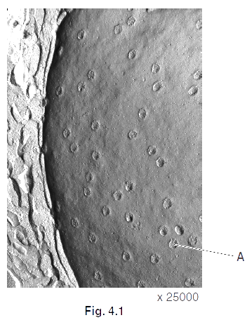

(i) A student stated that Fig. 4.1 was taken using a scanning electron microscope.

What evidence supports the student’s statement?

_____________________________________________________________________________________________________

_____________________________________________________________________________________________________

[1]

(ii) On Fig. 4.1, the nuclear pore complex, labelled A, is 3 mm wide.

Calculate the actual diameter of the pore, in nanometres.

__________nm [2]

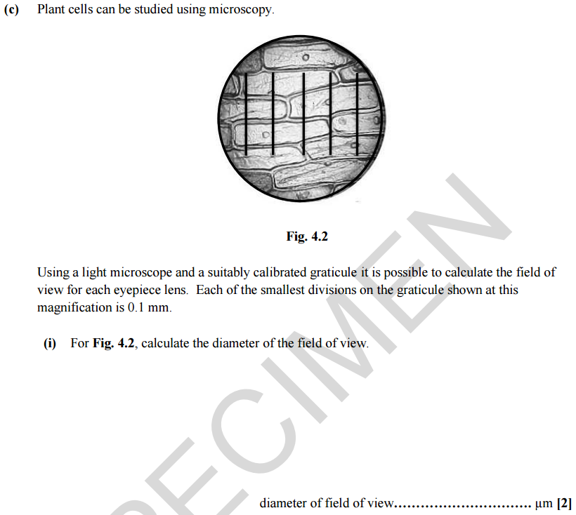

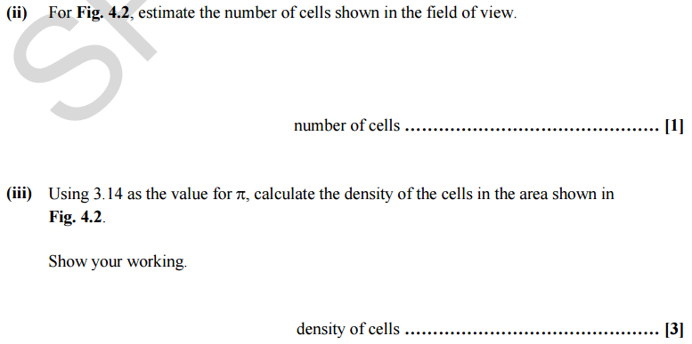

[Total: 11]

Question: 2

1 Fig. 1.1 is a diagram of a plant cell.
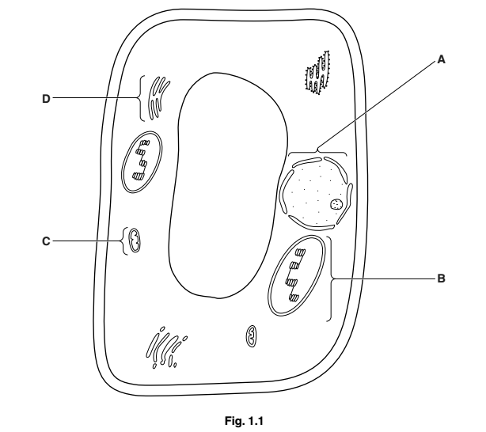

(a) (i) Name the cell components labelled A and B.

A ........................................................................................................................................

B ........................................................................................................................................

[2]

(ii) State the functions of the components labelled C and D.

C _____________________________________________________________________________________________________

D _____________________________________________________________________________________________________

[2]

(b) A student suggested that the details of component C could be seen clearly with a very good light microscope.

Explain why the student is not correct.

_____________________________________________________________________________________________________

_____________________________________________________________________________________________________

_____________________________________________________________________________________________________

__________________________________________________________________________________________________ [2]

(c) Staining is a process often used in microscopy.

Describe the advantages of staining specimens to be viewed under a microscope.

_____________________________________________________________________________________________________

_____________________________________________________________________________________________________

_____________________________________________________________________________________________________

_____________________________________________________________________________________________________

[2]

[Total: 8]

Question: 3

Fig. 2.1 is a diagram of a cell showing the organelles involved in the production and secretion of an extracellular protein. The rough endoplasmic reticulum (RER) is shown enlarged at the side of the diagram.
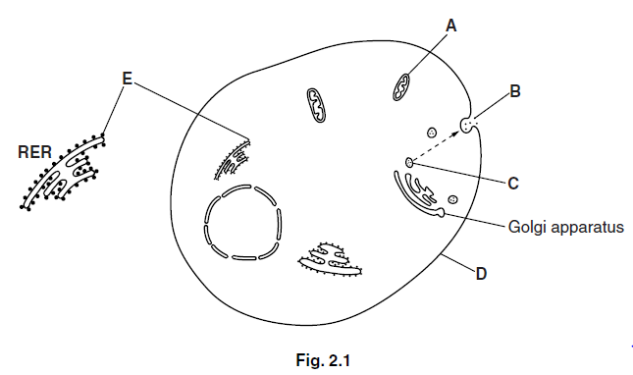

(a) (i) Name the structures labelled C, D and E.

C ____________________________________________________________________________________________

D ____________________________________________________________________________________________

E _____________________________________________________________________________________________

[3]

(ii) Suggest one type of extracellular protein secreted at B.

_____________________________________________________________________________________________________ [1]

(iii) Organelle A provides ATP which is a source of energy.

Suggest one stage during the secretion of a protein that requires energy.

_____________________________________________________________________________________________________ [1]

(iv) Outline the role of the Golgi apparatus.

_____________________________________________________________________________________________________

_____________________________________________________________________________________________________

_____________________________________________________________________________________________________

_____________________________________________________________________________________________________

_____________________________________________________________________________________________________

[2]

(b) The cell shown in Fig. 2.1 is a eukaryotic cell.

(i) Identify two features, visible in Fig. 2.1, which would not be present in a prokaryotic cell.

_____________________________________________________________________________________________________

_____________________________________________________________________________________________________

_____________________________________________________________________________________________________ [2]

(ii) Name one feature that would be present in the cytoplasm of a prokaryotic cell that is not found in a eukaryotic cell.

_____________________________________________________________________________________________________ [1]

[Total: 10]

