AS-Level Biology

Revision Pack

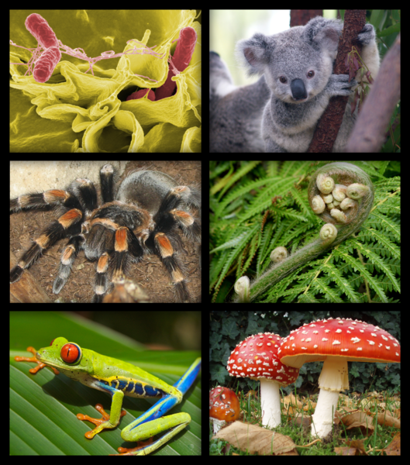

Unit 2: The Variety of Living Organisms

Name:___________________ Teacher:___________________

Variation

***­Interspecific variation:*** *When one species differs from another species.*

***Intraspecific variation:*** *When members of the same species differ from each other.*

Sampling: This involves taking measurements of individual, selected from the population being investigated. If these individuals are representative then the measurements can be relied upon.

***Sampling bias:*** *The selection process may be biased. The investigators may make unrepresentative choices.*

***Chance:*** *The individuals chosen may be not representative.*

The best way to prevent sampling bias is to eliminate human involvement in choosing the samples. This can be achieved by random sampling.

1. Divide study area into a grid of numbered lines.
2. Using random numbers obtain a series of coordinates.
3. Take samples at the intersection of each pair of coordinates.

We cannot remove chance completely but can minimise its effect by:

- **Using a large sample size:**  The more individuals selected the smaller the probability that chance will influence the result. The greater the sample size the more reliable the data.

- **Analysis of the data collected:** The data can be analysed using statistical tests to determine the extent chance has influenced the data.

Variation is the result of two main factors: genetic differences and environmental influences.

**Genetic differences**

These are due to the different genes that each individual organism possessed. These change from generation to generation. Genetic variation occurs as a result of:

**Mutations:** These sudden changes to genes and chromosomes may be passed to the next generation.

**Meiosis:** This form of nuclear division forms the gametes. This mixes the genetic material before it is passed to the gametes.

**Fusion of gametes:** In sexual reproduction, offspring inherit some characteristics of each parent. Which gamete fused with which a random process adds to variety.

**Environmental influences**

- Light

- Climatic conditions

- Soil conditions

- pH

- Food availability

DNA and meiosis

Nucleotide structure:

O.B

D.S

- A sugar called deoxyribose.

- A phosphate group.

- An organic base belonging to one of two groups: (a) Single-ring: cytosine and thymine.

(b) Double-ring: adenine and guanine.

The deoxyribose sugar, phosphate group and organic bases are a result of condensation reactions to give a **mononucleotide**.

Two nucleotides combine to form a **dinucleotide.**

The continuous linking of monucleotides forms a long chain known as a **polynucleotide.**

DNA structure:

In 1953, Watson and Crick worked out the structure of DNA.

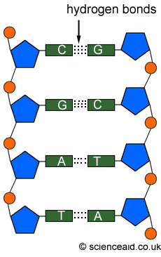DNA is made of two strings of nucleotides each of which is extremely long. They are joined by hydrogen bonds formed between bases.

Pairing of bases

The organic bases contain nitrogen and are of two types.

Those with a double-ring structure have longer molecules than those with a single-ring structure.

- Adenine always pairs with thymine by two hydrogen bonds.

- Guanine always pairs with cytosine by three hydrogen bonds.

Adenine is said to be complementary to thymine and guanine is said to be complementary to cytosine.

The function of DNA

DNA is adapted to carry out its functions in a number of ways:

- It is very stable and can pass to generations without change.

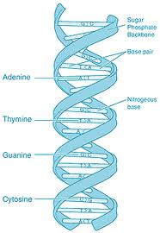- Its two separate strands are joined only with hydrogen bonds which allow them to separate during replication.

- It is a large molecule and carries an immense amount of information.

- By having the base pairs in the helical cylinder the information is protected from being corrupted.

The triplet code

What is a gene?

Genes are sections of DNA that contain the coded info for making polypeptides.

The coded information is in the form of a specific sequence of bases.

Polypeptides combine to make proteins and so genes determine the proteins of an organism.

As enzymes control chemical reactions they are responsible for an organism’s developments and activities.

The triplet code

Scientist suggested that there must be a minimum of three bases that coded for each amino acid.

- Only 20 amino acids regularly occur in proteins.

- Each amino acid must have its own code of bases.

- Only four bases are present in DNA.

- If each based coded for a different amino acid, only four amino acids could be coded for.

- Using a pair of bases, 16 codes are possible.

- Three bases produce 64 codes.

Further experiments have revealed the following features of the triplet code:

- A few amino acids have only a single triplet code.

- The remaining amino acids have 2-6 triplet codes each

- The code is known as a degenerate code.

- The triplet code is always read in one direction.

- The start of a sequence is always the same triplet code.

- Three triplet codes do not code for any amino acid and are known as stop codes.

- The code is non-overlapping.

- The code is universal.

DNA and chromosomes

- In prokaryotic cells, such as bacteria, the DNA molecules are smaller; they form a circle and are not associated with protein molecules. They therefore do not have chromosomes.

- In eukaryotic cells, the DNA molecules are larger; they form a line and occur in association with proteins to form chromosomes.

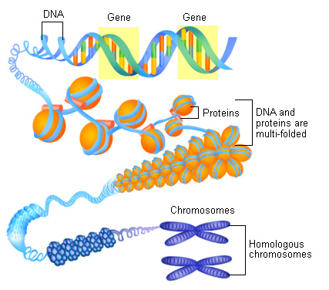Chromosome structure

- Only visible as distinct structure when a cell is dividing. The rest of the time they are widely dispersed throughout the nucleus.

- When visible they appear as two threads joined at a single point.

- Each thread is called a chromatid.

- The DNA in chromosomes is held in position by proteins.

- The length of DNA is highly coiled and folded.

The DNA is coiled and the looped and further coiled before being packed into the chromosome.

The number of chromosomes varies from one species to another. For example humans have 46 chromosomes whereas, potato pants have 78. In almost all species there is an even number of chromosomes in the cells of adults this is because they occur as homologous pairs.

Homologous chromosomes:

Sexually produced organisms are the result of the fusion of a sperm and egg. One of each pair is derived from the chromosomes provided by the mother and the other derived from the chromosomes provided by the father. These are known as homologous pairs and the total number is referred to as the diploid number.

During meiosis halving the number of chromosomes is done in a manner which ensures each daughter cell receives one chromosome from each homologous pair.

What is an allele?

Each gene exists of two, or occasionally more different forms. Each of these forms is called an allele. Each individual inherits one from each parent.

Any differences in the base sequence of an allele may result in a different sequence of amino acids being coded for.

Meiosis and genetic variation

The division of the nucleus of cells occurs in one of two ways:

- **Mitosis** produces 2 daughter nuclei with the same number of chromosomes as the parent cell and as each other.

- **Meiosis** produces 4 daughter nuclei, each with half the number of chromosomes as the parent cell.

Why is meiosis necessary?

In sexual reproduction two gametes fuse to give rise to new offspring. If each gamete has a full set of chromosomes then the cell they produce has double the number.

This doubling of the number of chromosomes would continue at each generation.

In order to maintain a constant number of chromosomes in the adults the number must be halved at some stage.

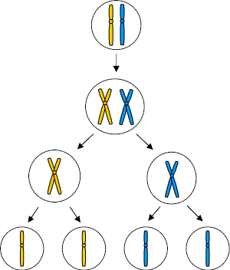

The process of meiosis

Meiosis involves two nuclear divisions that normally occur one after the other:

1. In the **first division** the homologous chromosomes pair up and their chromatids wrap around each other. Equivalent portions of these chromatids may be exchanged in a process called **crossing over**. By the end of this stage the homologous pairs have separated with one chromosome from each pair going into one of the two daughter cells.
2. In the **second meiotic division** the chromatids move apart. At the end 4 cells have been formed.

Independent segregation of homologous chromosomes

During meiosis 1, each chromosome lines up along its homologous partner. When these homologous pairs arrange themselves in line they do it randomly. Which one of the pair goes into the daughter cell and with which one of the pairs depends on how they are lined up.

Since they are lined up randomly the combination of chromosomes that goes into the daughter cell is also random. This is called independent segregation.

Crossing over:

- The chromatids of each pair twist around each other.

- During this tensions are created and portions break off.

- These portions rejoin with chromatids of its homologous partner.

- The equivalent portions are exchanged.

- A new genetic combination is produced.

Genetic diversity

The greater the number of alleles that all members of a species possess, the greater the genetic diversity of the species.

The greater the genetic diversity, the more likely it is that a species will be able to adapt to some environmental change. This is due to a wider range of alleles and therefore a wider range of characteristics.

There is a greater probability that some individual will possess a characteristic that suits it to the new environmental conditions.

Selective breeding:

- Also known as artificial selection.

It involves selecting individuals with desired characteristics and using then to parent the next generation.

Offspring that don’t exhibit the characteristics are killed or prevented from breeding.

The variety of alleles in the population is deliberately restricted to a small number of desired alleles.

The founder effect:

- Occurs when few individuals colonise a new region.

They carry with them only a small fraction of the alleles of the population.

These alleles may not be representative.

The new population that develops from the few colonisers will show less genetic diversity than the population they came from.

Genetic bottle necks

Populations may sometimes suffer a drop in numbers.

This may be due to things such as a volcanic eruption or interference by man.

The few survivors will possess a smaller variety of alleles than the original population.

As they breed and become re-established the genetic diversity will remain restricted.

Ethics of selective breeding:

-Interfering with nature?

- Animal rights and welfare?

- Is it beneficial to the environmental?

- Cost?

Haemoglobin

Haemoglobin molecules:

- ***Primary structure:*** *Four polypeptide chains.*

*-* ***Secondary structure:*** *Each of the polypeptide chains are coiled into a helix.*

*-* ***Tertiary structure:*** *Each polypeptide chain is folded into a precise shape.*

*-* ***Quaternary structure:*** *All four polypeptides are linked to form a spherical molecule. Each polypeptide is associated with a haem group which contains an iron ion- combines with a single O2 molecule making four O2 molecules carried by a single haemoglobin molecule.*

The role of haemoglobin:

The role of haemoglobin is to transport oxygen. To be efficient at transporting oxygen it must:

- Readily associated with oxygen at the surface where gas exchange takes place.

- Readily dissociate from oxygen at tissues requiring it.

In the presence of carbon dioxide, the new shape of haemoglobin binds more loosely to oxygen which makes haemoglobin release its oxygen.

Why have different haemoglobins?

**Haemoglobins with a high affinity for oxygen-** Take up oxygen more easily but release it less readily.

**Haemoglobin with a low affinity for oxygen-** Take up oxygen less easily but release it more readily.

Scientists found a correlation between the type of haemoglobin in an organism and factors in which it lived or its metabolic rate. Explanations are as follows:

- An organism in an environment with little oxygen requires haemoglobin that readily combines with oxygen

- An organism with a high metabolic rate needs to release oxygen readily into its tissues.

Loading and unloading oxygen

The process when haemoglobin combines with oxygen is called **loading** or **associating.**

The process where haemoglobin released its oxygen is called **unloading** or **dissociating.**

Oxygen dissociation curves

When haemoglobin is exposed to different partial pressures of oxygen it doesn’t absorb it evenly. At low concentrations of oxygen the four polypeptides of the haemoglobin molecule are closely united and so it’s difficult to absorb the first oxygen molecule.

The graph tails off at very high oxygen concentrations because haemoglobin is almost saturated with oxygen.

The further to the left of the curve, the greater the affinity for oxygen (takes up readily but releases less easily).

The further to the right of the curve, the lower the affinity for oxygen (takes up less readily but releases more easily).

Effects of carbon dioxide concentration

Haemoglobin has a reduced affinity for oxygen in the presence of carbon dioxide.

The greater the concentration of carbon dioxide the more readily the haemoglobin releases its oxygen.

- At the gas exchange surface the level of CO2 is low because it diffuses across the exchange surface and is expelled. The affinity for oxygen is increased which means that oxygen is readily loaded by haemoglobin.

- In respiring tissues the level of CO2 is high. The affinity for oxygen is reduced which means oxygen is readily unloaded from haemoglobin into the muscle cells.

Loading, transport and unloading of oxygen

- At the gas-exchange surface CO2 is constantly being removed.

- The pH is raised due to the low level of CO2.

- The higher pH changes the shape of haemoglobin into one that loads oxygen readily.

- The shape increases the affinity for oxygen so it’s not released during transportation.

- In the tissues CO2 is produced by respiring cells.

- CO2 is acidic in solution so the pH of the blood in the tissues is lowered.

- The lower pH changed the shape of haemoglobin into one with a lower affinity for oxygen.

-Haemoglobin releases its oxygen into respiring tissues.

The higher the rate of respiration, the more CO2 the tissues produce.

The lower the pH, the greater the haemoglobin shape changes.

The more readily oxygen is unloaded, the more oxygen available for respiration.

Starch, glycogen and cellulose

Starch

This is a polysaccharide found in parts of a plant in the form of small grains.

It forms a large component of food and is the energy source in most diets.

Starch is made up of chains of α-glucose monosaccharides linked by glycosidic bonds formed by condensation reactions.

The unbranched chain is wound into a tight coil that makes the molecule very compact.

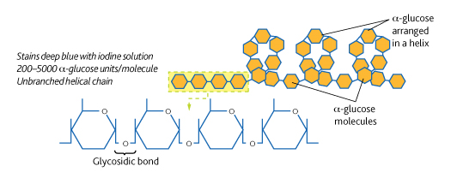Starch is suited for energy storage because:

- It’s insoluble and doesn’t draw water into cells.

- It doesn’t easily diffuse out of cells.

- It’s compact so a lot can be stored in a small space.

- When hydrolysed it forms α-glucose which is easily transported and readily used in transpiration.

Glycogen

This is similar to starch but has shorter chains and is more highly branched. In animals it is stored as small granules mainly in the muscles and liver.

Cellulose

This differs from starch and glycogen as it’s made of monomers and β-glucose. The main reasons for differences in the structure and function is that in the β-glucose units the positions of the –H group and the –OH group are reversed. In the β-glucose the –OH group is above the ring. This means to form glycosidic links the molecule must be rotated 180°.

Cellulose has straight unbranched chains that run parallel to one another allowing hydrogen bonds to form cross-linkages between adjacent chains.

The cellulose molecules are grouped to form microfibrils which are arranged in parallel groups called fibres.

Cellulose is a major component of plant cell walls and provides rigidity. The wall also prevents the cell from bursting as water enters by osmosis. It exerts an inward pressure that stops further influx of water.

Plant cell structure

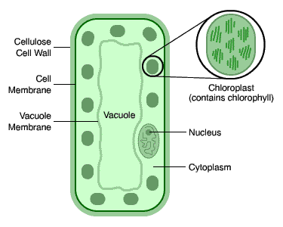Leaf palisade cell

The main features that suit it to photosynthesis include:

- Long, thin cells that form a layer to absorb sunlight.

- Chloroplasts that arrange themselves to collect max. amount of light.

- Large vacuole that pushes cytoplasm and chloroplasts to the edge of the cell.

Chloroplasts

These vary in shape and size but are disc-shaped, 2-10 µm and 1 µm in diameter. Their main features include:

* ***The chloroplast envelope:*** *A double plasma membrane that surrounds the organelle. It’s highly selective in what enters/exits the cell.*
* ***The grana:*** *Stacks of up to 100 thylakoids. Within these is the pigment chlorophyll. Some thylakoids have tubular extensions that join up with others in adjacent grana.*
* ***The stroma:*** *Fluid-filled matrix where the second stage of photosynthesis takes place.*

Chloroplasts are adapted to their function in the following ways:

- The granal membranes provide a large surface area for attachment of chlorophyll, electron carriers and enzymes that carry out the first stage of photosynthesis.

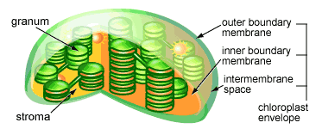- The fluid of the stroma possesses all enzymes needed to carry out the second stage of photosynthesis.

- Chloroplasts contain DNA and ribosomes so the can quickly manufacture proteins needed for photosynthesis.

Cell wall

- They consist of polysaccharides.

- There is a thin layer called the middle lamella, which marks the boundary between adjacent cell walls and cements them together.

The functions of the cellulose cell wall are:

- To provide mechanical strength.

- To allow water to pass along it.

|  |  |
| --- | --- |
| Plant cells | Animal cells |
| Cellulose cell wall surrounds the cell. | Only a cell-surface membrane surrounds cell. |
| Chloroplasts present in large numbers. | Chloroplasts are never present. |
| Large, single, central vacuole filled with sap. | If vacuoles are present they are small + scattered. |
| Starch grains used for storage. | Glycogen granules are used for storage. |

The cell cycle

Cell division occurs in two main stages:

- **Nuclear division** is the process where the nucleus divides. There are two types of nuclear division, mitosis and meiosis.

- **Cell division** follows nuclear division and is the process where the whole cell divides.

Before a nucleus divides its DNA must be replicated. This is to ensure that all the daughter cells have the genetic info to produce enzymes and proteins they need.

Semi-conservative replication

For this to take place there are four requirements:

- The four types of nucleotide, each with their bases must be present.

- Both strands of the DNA molecule must act as a template for the attachment of these nucleotides.

- The DNA polymerase is needed to catalyse the reaction.

- A source of chemical energy is required to drive the process.

The process of semi-conservative replication takes place as follows:

1. The DNA helicase breaks the hydrogen bonds linking the base pairs.
2. The double helix separates into its two strands and unwinds.
3. Each exposed polynucleotide acts as a template for complementary nucleotides to attach.
4. Energy is used to activate the nucleotides.
5. The nucleotides are joined by DNA polymerase to form the missing polynucleotide strand on each of the 2 original polynucleotide strands.
6. Each of the new DNA molecules contains one of the original DNA strands.

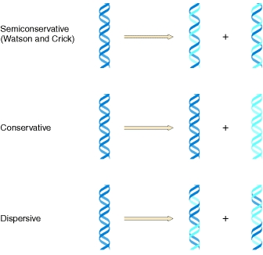

Mitosis

Nuclear division can take place by either mitosis or meiosis:

**Mitosis** produces two daughter nuclei that have the same number of chromosomes as the parent cell.

**Meiosis** produced four daughter nuclei, each with half the chromosomes of the parent cell.

Mitosis

This is the division of the nucleus of a cell that results in each of the daughter cells having an exact copy of the DNA of the parent cell. Except in the event of a **mutation**.

Mitosis is always preceded by a period during which the cell is not dividing. This is called **interphase**. It is a period of considerable cellular activity that included the replication of DNA.

1. **Prophase** in which the chromosomes become visible and the nuclear envelope disappears.
2. **Metaphase** in which the chromosomes arrange themselves at the centre of the cell.
3. **Anaphase** in which each of the two threads of a chromosome migrates to an opposite pole.
4. **Telophase** in which the nuclear envelope reforms.

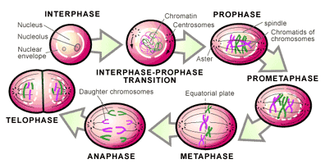

The importance of mitosis

Mitosis is important because it produces daughter cells that are identical to the parent cells.

- **Growth**: when 2 haploid cells fuse together, the diploid cell has all the genetic info needed to resemble its parents, all cells grown from this need to possess the same info.

- **Differentiation:** these cells change to give groups of specialised cells. The different cell types each divide by mitosis to give tissues made up of identical cells.

- **Repair:** if cells are damaged or die it’s important that the new cells have an identical structure and function to those lost.

The cell cycle

The cell cycle takes place in three stages:

1. **Interphase:** this occupies most of the cell cycle and is known as the resting phase because no division takes place.
2. First growth phase when proteins from which cell organelles are synthesised are produced.
3. Synthesis phase when DNA is replicated.
4. Second growth phase when organelles grow and divide and energy stores are increased.
5. **Nuclear division** when the nucleus divides either into two or four.
6. **Cell division** which follows nuclear division and is the process where the whole cell divides into two or four.

The length of a complete cell cycle varies greatly; a mammalian cell takes about 24 hours to complete a cycle of which about 90% is interphase.

Cancer

Cancer is a group of around 200 diseases caused by a growth disorder of cells.

It’s the result of damage to the genes that regulate mitosis and the cell cycle.

This leads to uncontrolled growth of cells and a tumour develops and expands in size.

Cancers are most commonly found in the lungs, prostate gland, breast and ovaries.

Cancer and its treatment

The treatment often involves blocking some part of the cell cycle. In this way the cycle is disrupted and cell division and cancer growth ceases. Drugs used to treat cancer disrupt the cycle by:

- Preventing DNA from replicating

- Inhibiting the metaphase stage by interfering with the spindle formation.

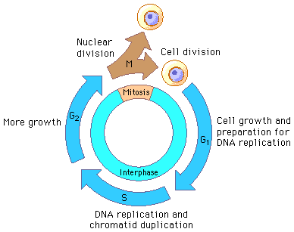The drugs also disrupt the cell cycle of normal cells.

Cellular organisation

Cell differentiation

Single-celled organism performs all essential life functions inside the boundaries of a single cell.

They cannot be totally efficient at all functions because each function requires a different type of cellular structure.

All cells in an organism are initially identical and as it matures, each cell takes on its own individual characteristics that suit it to the function it will perform when it’s mature.

Each cell becomes specialised in structure to suit it to its role (cell differentiation).

Tissues

Examples of tissues include:

- **Epithelial tissues**: these are found in animals and are sheets of cells that line the surface of organs. They often have a protective or secretory function and there are many types including those made up of thin, flat cells that line organs where diffusion takes place.

- **Xylem**: this occurs in plants and is made of a number of cell types. It’s used to transport water and mineral ions through the plant and gives mechanical support.

Organs

An organ is a combination of tissues that are coordinated to perform a range of functions.

In animals for example the stomach is made up of tissues such as:

- ***Muscle*** to churn and mix stomach contents.

- ***Epithelium*** to protect the wall and produce secretions.

- ***Connective tissue*** holds other tissues.

In plants a leaf is made up of the following tissues:

- ***Palisade mesophyll*** made of leaf palisade cells that photosynthesize.

- ***Spongy mesophyll*** for gaseous diffusion.

- ***Epidermis*** to protect the leaf and allow gaseous diffusion.

- ***Phloem*** to transport organic materials away from the leaf.

- ***Xylem*** to transport water and ions into the leaf.

Organ systems

- ***The digestive system:*** *Digests and processes food, is made up of organs including the salivary glands, oesophagus, stomach etc.*

*-* ***The respiratory system:*** *Used for breathing and gas exchange. It’s made up of organs that include the trachea, bronchi and lungs.*

*-* ***The circulatory system:*** *Pumps and circulates blood. It is made up of organs that include the heart, arteries and veins.*

Exchange and transport

Examples of things which need to be interchanged between an organism and its environment include:

* Respiratory gases
* Nutrients
* Excretory products
* Heat

This exchange can take place in two ways:

* Passively by diffusion and osmosis
* Actively by active transport

Surface area to volume ratio

For exchange to be effective, the surface area of the organism must be large compared to the volume.

As organisms become larger, their volume increases at a father rate than their surface area.

*To overcome the problem organisms have evolved some of the following features:*

- A flattened shape so no cell is far from the surface.

- Specialised exchange surfaces with large area to increase the surface area to volume ratio.

Features of specialised exchange surfaces:

* A large surface area to volume ratio to increase the rate of exchange.
* Thin so the diffusion path is short.
* Partially permeable to allow selected materials to cross.
* Movement of the environmental medium.
* Movement of the internal medium.

Width Length

Height

Gas exchange in single-celled organisms and insects

Gas exchange in single-celled organisms:

Oxygen is absorbed by diffusion across their body surface.

Carbon dioxide from respiration diffuses out across their body surface.

Gas exchange in insects

The problem for all terrestrial organisms is that water easily evaporates from the surface of their bodies and they become dehydrated.

To reduce water loss, terrestrial organisms exhibit two features:

- ***Waterproof coverings*** *rigid outer skeleton in insects.*

***- Small surface area to volume ratio*** *to minimise the area over which water is lost.*

These features mean insects can’t use their body surface to diffuse respiratory gases. They have therefore developed an internal network of tubes called **tracheae.** These are supported by **strengthened rings** to prevent them from collapsing. The tracheae divide into smaller tubes called **tracheoles**. The tracheoles extend through the body tissues.

Respiratory gases move in and out of the tracheal system in two ways:

- **Along a diffusion gradient:** During respiration, oxygen is used and the concentration at the ends of the tracheoles decreases. This creates a diffusion gradient that causes gaseous oxygen to diffuse from the atmosphere along the tracheae and tracheoles to cells.

Carbon dioxide is produced during respiration which creates a diffusion gradient in the opposite direction. This causes gaseous carbon dioxide to diffuse along the tracheoles and tracheae from cells to the atmosphere.

- **Ventilation:** The movement of muscles in insects can create mass movements of air in and out of the tracheae.

Gases enter and leave tracheae through **spiracles**. These may be opened and closed by a valve. When they are open water can evaporate so most of the time they are close to prevent water loss.

Gas exchange in fish

Fish have a waterproof, gas-tight outer covering. They also have a small surface area to volume ratio. Their body surface is not adequate to supply and remove their respiratory gases and so they have developed a specialised internal gas exchange surface.

Structure of the gills

The gills are located in the body of the fish behind the head. They are made up of **gill filaments.** These are stacked up in a pile and at right angles to the filaments are **gill lamellae**, which increase surface area of the gills.

Water is taken in through the mouth, forced over the gills and through an opening on the side of the body.

The flow of water over the gill lamellae and the blood within them are in opposite directions which is known as **counter current flow**.

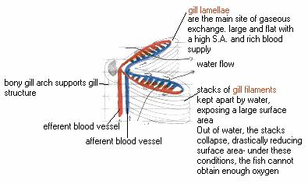

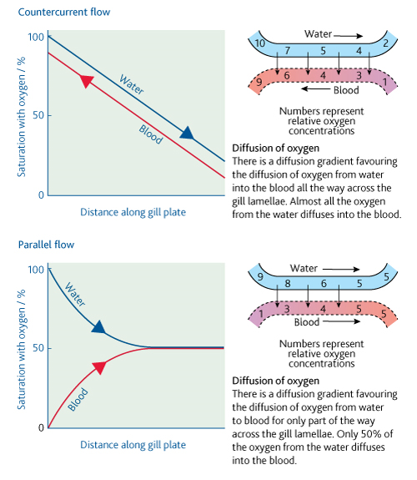

The counter current exchange principle

- Blood is already well loaded with oxygen meets water which has its max concentration of oxygen. This means diffusion of oxygen from water to blood takes place.

- Blood with little or no oxygen meets water which has had most but not all of its oxygen removed. Diffusion of oxygen from water to blood takes place.

Gas exchange in the leaf of a plant

When photosynthesis is taking place some carbon dioxide comes from respiration of cells. Most of it is obtained from external air in the same way oxygen from photosynthesis is used in respiration but most diffuses out of the plant.

When photosynthesis is not occurring, oxygen diffuses into the leaf as it is constantly being used by cells during respiration. In the same way carbon dioxide diffuses out during respiration.

Structure of a plant leaf and gas exchange

There is a short diffusion pathways and a plant leaf has a very large surface area to volume ratio.

Most gaseous exchange occurs in leaves which show the following adaptations for quick diffusion:

- Thin, flat shape that provides a large surface area.

- Stomata, mostly in the lower epidermis.

- Interconnecting air-spaces that occur throughout the mesophyll.

Stomata

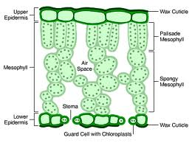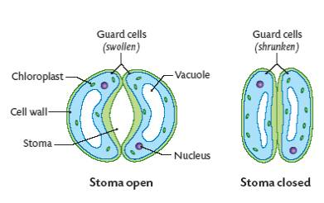These are minute pores which occur mainly in the leaves. Each stoma is surrounded by a pair of special cells (guard cells). These can open and close the stomatal pore. Therefore they can control the rate of gaseous exchange.

Circulatory system of a mammal

Why large organisms need a transport system

With increasing size, the surface area to volume ration decreases so the needs of the organism cannot be met by the body surface.

A specialist exchange surface is needed to absorb nutrients and respiratory gases and to remove excretory products. These are located in specific regions of the organism.

A transport system is required to take materials from cells to exchange surfaces and vice versa.

Whether of not there is a specialised transport medium and whether or not It’s circulated by a pump depends on 2 factors:

- The surface area to volume ratio.

- How active the organism is.

Features of transport systems

- A suitable medium to carry materials (normally liquid based on water).

- Form of mass transport.

- A closed system of tubular vessels that contains the transport medium and forms a branching network to distribute it.

- A mechanism for moving the transport medium within the vessels.

(a) Animals use muscular contraction.

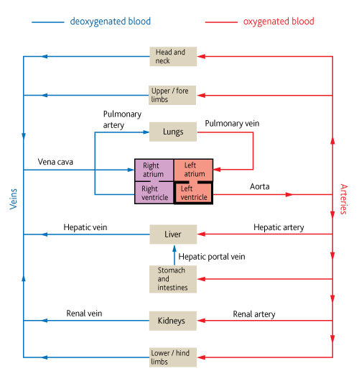 (b) Plants rely on physical processes.

- A mechanism to maintain the mass flow in one direction.

- A means of controlling the flow of the transport medium.

Transport systems in mammals.

Mammals have a close blood system where blood is confined to vessels. The heart circulates the blood around the body.

Mammals have a double circulatory system; this means blood passes twice through the heart for each complete circuit.

Blood vessels and their functions

Structure of blood vessels

- **Arteries** carry blood away from the heart into the arterioles.

- **Arterioles** are smaller arteries that control blood flow from arteries to capillaries.

- **Capillaries** are tiny vessels that link arterioles to veins.

- **Veins** carry blood from capillaries back to the heart.

Arteries, arterioles and veins all have the same layered structure:

- **Tough outer layer-** resists pressure changes.

- **Muscle layer-** contract and control the flow of blood.

- **Elastic layer-** maintains blood pressure by stretching and springing back.

- **Thin inner lining-** prevents friction and allows diffusion.

- **Lumen-** central cavity of the blood vessel where blood flows.

Artery structure related to function

- **Muscle layer is thicker than veins:** Smaller arteries can be constricted and dilated to control the volume of blood passing through.

- **Elastic layer is thicker than veins:** The wall is stretched at the beat of the heart and springs back when the heart relaxes. This helps maintain a high pressure.

- **Overall thickness of the wall is large:** Resists the vessel bursting under pressure.

- **There are no valves:** Because blood is under constant high pressure.

Arteriole structure related to function

­- **Muscle layer is thicker than arteries:** The contraction of this layer allows constriction of the lumen. This restricts the flow of blood and controls its movement.

- **Elastic layer is thinner than arteries:**  Because blood pressure is lower.

Vein structure related to function

- **Muscle layer is thin:** Because veins carry blood away from tissues.

- **Elastic layer is thin:** Because low pressure of blood will not cause them to burst.

- **Thickness of wall is thin:** As pressure is low.

- **There are valves:** To prevent backflow.

Capillary structure

- **Walls consist of lining layer:** For short diffusion distance.

- **Numerous and highly branched:** Large surface area.

- **Narrow diameter:** Permeate tissues.

- **Lumen is narrow:** Reduces diffusion distance.

- **Spaces between lining:** So white blood cells can escape.

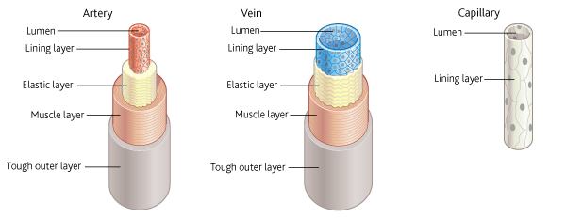Tissue fluid and its formation

Tissue fluid contains glucose, amino acids, fatty acids, salts and oxygen.

It’s formed in the blood plasma.

Blood pumped around the heart creates hydrostatic pressure at the arterial end of the capillaries which forces tissue fluid out of blood plasma.

The outward pressure is opposed by:

- Hydrostatic pressure of tissue fluid outside capillaries

- Lower water potential of the blood.

The pressure is only enough to force small molecules out leaving cells and proteins in the blood. This is called **ultra filtration.**

Return of tissue fluid to the circulatory system.

- The loss of the tissue fluid from the capillaries reduces the hydrostatic pressure inside.

- By the time the blood reaches the venous end the hydrostatic pressure is less than the tissue fluid outside of it.

- Tissue fluid is forced back into the capillaries.

-Osmotic forces pull water back into the capillaries.

Not all the tissue fluid can return to the capillaries so the remainder is carried back via the lymphatic system.

This is a system of vessels that begin in the tissues.

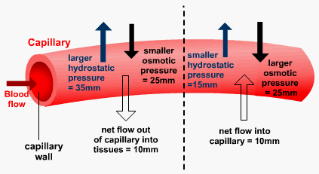The contents of the lymphatic system are moved by:

- **Hydrostatic pressure**

**- Contraction of body muscles.**

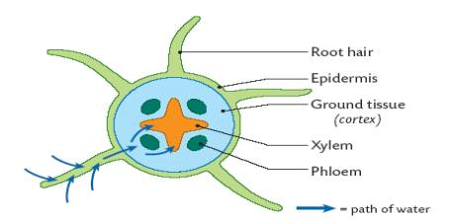Movement of water through roots

Uptake of water by root hairs

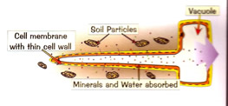Each root hair is a long, thin extension of a root epidermal cell. They are efficient surfaces for the exchange of water and mineral ions because:

- They provide a large surface area as they are long.

- They have a thin surface layer.

Root hair cells arise from epidermal cells. They grow into the spaces around soil particles. In damp conditions they are surrounded by a soil solution which contains mineral ions.

The solution has a high water potential.

Root hairs have sugars, amino acids and mineral ions dissolved inside of them. Therefore they have a lower water potential. Water then moves by osmosis from the soil into the root-hair cells down the water potential gradient.

The apoplastic pathway:

As water is drawn into endodermal cells, it pulls more water along due to the cohesive properties of the water molecules.

This creates a tension that draws water along the cell walls. The mesh-like structure of the cellulose cell walls has water-filled spaces so there is little resistance to the pull of water.

The symplastic pathway:

This takes place across the cytoplasm as a result of osmosis.

The water passes through the cell walls along the plasmodesmata. Each plasmodesma is filled with cytoplasm.

1. Water entering by osmosis increases the water potential of the r.h.c.
2. The r.h.c has a higher w.p than the first cell in the cortex.
3. Water moves from the r.h.c to the first cell by osmosis.
4. The first cell has a higher w.p than its neighbour in the stem.
5. Water moves into the neighbour.
6. The neighbour has a higher w.p so it moves to the 3rd cell.
7. The loss of water from the first cell lowers its water potential causing more water to enter.
8. A water potential gradient is set up which carries water along the cytoplasm to the endodermis.

Passage of water into the xylem

When the water reaches the endodermis the waterproof band making up the Casparian strip prevents it progressing. Water is then forced into the protoplast where it joins water that’s arrived by the symplastic pathway.

Active transport of salts is most likely to allow water into the xylem. This requires energy and takes place along carrier proteins.

The active transport of mineral ions creates lower water potential in the xylem. Water moves into the xylem by osmosis which creates a force to move water up the plant (root pressure).

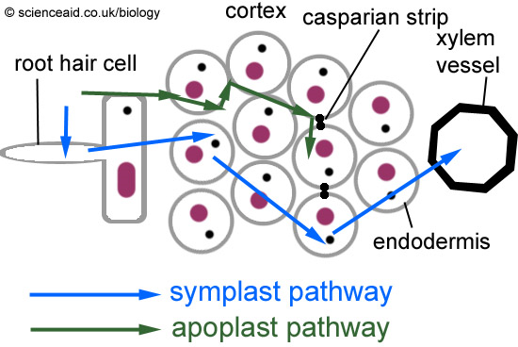

Movement of water up stems

The force that pulls water up the stem of a plant is a process called transpiration.

Movement of water out through stomata

The humidity of the atmosphere is less than of the air spaces next to the stomata. If the stomata are open, water vapour molecules diffuse out into surrounding air. Water lost from the air spaces is replaced by evaporating water from cell walls of the mesophyll cells.

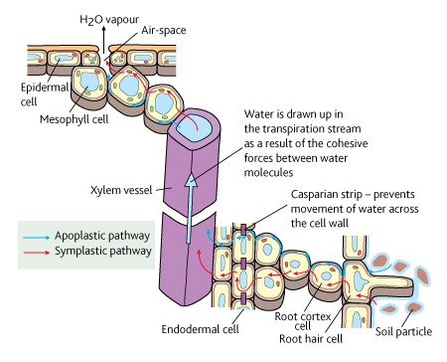Movement of water across the cells of a leaf

Water is lost from mesophyll cells by evaporation to the air spaces of the leaf. This is replaced by water reaching the mesophyll cells from the xylem by either the apoplastic or symplastic pathways.

In the case of the symplastic pathway, the water movement occurs because:

- Mesophyll cells lose water to air spaces.

- The cells have lower water potential so water enters.

- Loss of water from neighbouring cells lowers their water potential.

- They take in water from their neighbours by osmosis.

Movement of water up the stem in the xylem

The two main factors responsible for the movement of water up the xylem are **cohesion-tension** and **root pressure.** The cohesion-tension theory operates as follows:

1. Water evaporates from leaves by transpiration.
2. Water molecules form H bonds and stick together (cohesion).
3. Water forms a continuous pathway across mesophyll cells and down the xylem.
4. As water evaporates from the mesophyll cells more molecules are drawn up.
5. Water is pulled up the xylem (transpirational pull)
6. Transpirational pull puts xylem under tension.

There are several pieces of evidence to support the theory:

- Change in diameter of trunks (day= more tension night=less tension= trunk shrinks)

- If xylem vessel is broken tree can’t draw up water.

- If vessel is broken water doesn’t leak out.

Transpirational pull is passive so it doesn’t require energy. The xylem vessels are dead so can’t actively move the water.

Transpiration and factors affecting it

Role of transpiration

Leaves have a large surface area to absorb light and stomata allow inward diffusion of CO2. Both features result in loss of water. Transpiration is not essential because osmosis could achieve this.

Materials e.g. mineral ions, sugars and hormones are moved around the plant. The water carrying them is carried up the plant by transpirational pull.

Factors affecting transpiration

* ***Light:*** *Stomata are the openings where CO2 diffuses. Photosynthesis only occurs when there’s light so stomata are open and close in the dark. When open water leaves into the atmosphere. Increase in light increases the rate of transpiration.*
* ***Temperature:*** *This affects how much water air can hold and the speed at which water molecules move. A rise in temperature increases kinetic energy and speed of water molecules therefore increasing evaporation. It also decreases the amount of water air can hold.*
* ***Humidity:*** *This is the measure of the number of water molecules in the air. Humidity affects the water potential gradient between the air outside + inside the leaf. When air outside has high humidity the gradient is reduced and rate of transpiration is lower.*
* ***Air movement:*** *As water diffuses through stomata, it collects as vapour around them on the inside of the leaf. The water potential is therefore increased which reduces the water potential gradient between the atmosphere and air spaces. The transpiration rate is therefore reduced.*

|  |  |  |  |
| --- | --- | --- | --- |
| Factor | How it affects  transpiration | Increase in  transpiration  caused by: | Decrease in  transpiration  caused by: |
| Light | Stomata open in light  and close in the dark. | Higher light intensity. | Lower light intensity. |
| Temperature | Alters kinetic energy  of water molecules and  the humidity of the air. | Higher temperature. | Lower temperature. |
| Humidity | Affects water potential  gradient between air-  spaces in leaf and the  atmosphere | Lower humidity. | Higher humidity. |
| Air  movement | Changes water potential  gradient by altering rate  that moist air is removed. | More air movement. | Less air movement. |

Limiting water loss in plants

Xerophytic plants

Plants that do not have a plentiful water supply have developed a range of other adaptations to limit water loss through transpiration. These plants are called **xerophytes.**

These are plants that are adapted to living in areas where their water losses due to transpiration may exceed their water uptake. Their modifications to reduce water loss include:

* **Thick cuticle:** The thicker the cuticle, the less water can escape. Many evergreen plants for example holly have thick cuticles to reduce water loss especially during winter.
* **Rolling up of leaves:** Most leaves have their stomata confined to the lower epidermis. The rolling of leaves protects the lower epidermis from the outside and helps trap a region of still air. The region becomes saturated with water vapour so there is no water potential gradient between the inside and outside. Plants such as marram grass roll their leaves.
* **Hairy leaves:** A thick layer of hairs on leaves help trap moist air next to the leaf surface. The water potential gradient between inside and outside is reduced therefore less water is lost through transpiration. One type of heather plant has this.
* **Stomata in pits or grooves:** These also trap moist air and reduce the water potential gradient. Pine trees use this modification.
* **Reduced surface area to volume ratio of the leaves:** By having leaves that are small and roughly circular in cross-section e.g. pin needles, the rate of water loss can be reduced.

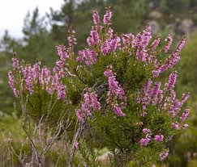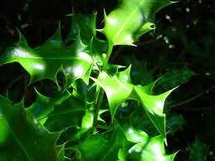

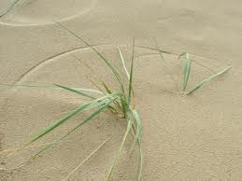

Classification

Scientists estimate that the numbers of species on Earth are from 10 million to 100 million.

Classification is the organisation of living organisms into groups. This process is based on a number of accepted principles.

The concept of a species

The definition of a species is not easy, but members of a single species have certain things in common:

- **They are similar to one another but different from other species:** They have very similar genes and closely resemble each other physically and biochemically. They have similar patterns of development and occupy the same ecological niche.

- **They are capable of breeding:** This means when a species reproduces, any of the genes of the genes of its individuals can be combined and belong to the same gene pool.

Naming species- the binomial system

Over 200 years ago the Swedish botanist Linnaeus devised a common system of naming organisms. Its features are as follows:

- It’s a universal system based on Greek or Latin names.

- The first name, the generic name, denotes the genus to which the organism belongs.

- The second name, the specific name, denotes the species where the organism belongs.

There are a number of rules applied to the use of the binomial system in scientific writing:

- The names are printed italics or if handwritten underlined.

- The first letter of the generic name is in upper case but the specific name in lower case.

- The specific name is not known and can be written as ‘sp’.

Grouping species together- the principles of classification

The theory and practise of biological classification is called taxonomy.

There are two forms of biological classification:

- **Artificial classification:** Divides according to differences such as colour, size, number of legs etc. These are analogous characteristics where the have the same function but not the same evolutionary origins.

- **Natural classification:**

a) Based on evolutionary relationships between organisms + ancestors.

b) Classifies species into groups sharing features derives from ancestors.

c) Arranges into a hierarchy.

Organising the groups of species- taxonomy

Each group is called a taxon. The groups are positioned in a hierarchal order called taxonomic ranks. The largest group is called a kingdom within each kingdom the largest groups are known as phyla.

Phylogeny

The phylogeny of an organism reflects the evolutionary branch that led up to it. The phylogenetic relationships of different species are represented by a tree like diagram called a phylogenetic tree.

The difficulties of defining species

- Species are not fixed forever and change and evolves over time.

- Within a species is a lot of variation.

- Many species are extinct.

- Some species rarely reproduce.

- Members of different groups of the same species may be isolated and never meet or interbreed.

- Groups of isolated organisms may be classified as a different species.

- Some species are sterile.

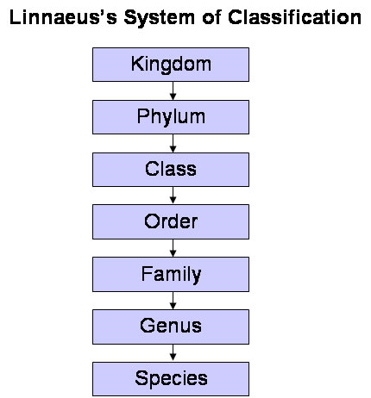

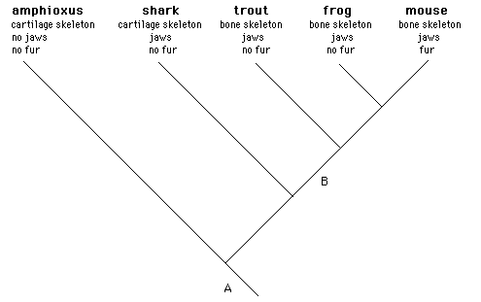

Evidence for relationships between organisms

Comparison of DNA base sequences

When one species gives rise to another during evolution, the DNA of the new species will be similar to the species that gave rise to it.

Due to mutations, the sequences of nucleotide bases will change. Over time the new species will accumulate more and more differences in its DNA.

One way to determine similarities between the DNA of different organisms is to use DNA hybridisation.

DNA hybridisation

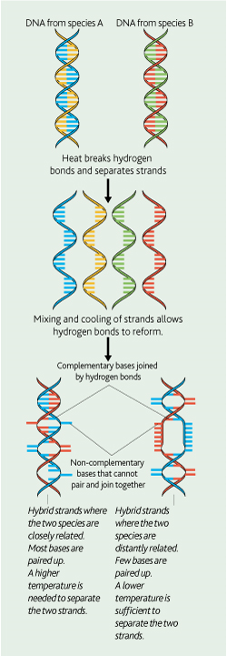This depends upon a particular property of the DNA double helix. When DNA is heated, its double strand separates into two complementary strands. When cooled, the bases on each strand recombine with each other to reform the original double strand.

DNA hybridisation can be used to compare the DNA of the two species in the following way:

1. DNA from 2 species is extracted, purified and cut.
2. DNA from one species is labelled with a radioactive or fluorescent marker + mixed with the other DNA.
3. Mixture of DNA is heated to separate the strands.
4. It’s cooled to allow the strands to combine.
5. Some double strands that reform will be made of one strand from each species (hybridisation). New strands are called hybrid strands (50% labelled).
6. Hybrid strands are separated out and temp is increased.
7. At each temp stage the degree that the 2 strands are linked is measured.
8. If the species are closely related they will share complementary bases.
9. More H bonds linking them in the hybrid strand.
10. The greater the amount of H bonds the stronger the hybrid strand.
11. The stronger the strand the higher the temp to separate it.
12. The higher the temp where it splits, the more related the 2 species are.

Use of DNA base sequencing in classifying plants

The recent classification of flowering plants has led to them being placed in one of two groups. The monocotyledons that have a single seed leaf (thin, narrow leaves) and the dicotyledons that have two seed leaves (broad leaves).

Scientists at The Royal Botanical Gardens, Kew devised a new classification of the families of flowering plants based on the DNA sequences of three genes found in all plants:

- They used 565 species that represented all the known families of flowering plants.

- For each plant, the DNA sequences of all 3 genes were determined.

- The sequences for each species were compared using computers.

- A phylogenetic tree was devised based upon the DNA sequences.

Comparison of amino acid sequences in proteins

The degree of similarity in the amino acid sequence of the same protein in 2 species will reflect how closely related they are.

Once the amino acid sequence for a chosen protein has been determines the 2 sequences are compared by counting similarities or differences in each sequence.

Immunological comparisons of proteins

The proteins of different species can also be compared using immunological techniques. The principle behind the method is that antibodies of one species will respond to antigens on proteins in the blood serum of another.

The process is carried out as follows:

* Serum albumin from species A is injected to B.
* Species B produces antibodies specific to antigen sites on the albumin from A.
* Serum is extracted from B that contains antibodies specific to antigens on albumin for A.
* Serum from B is mixed from serum from blood of a third species C.
* The antibodies respond to their corresponding antigens on the albumin of C.
* The response is the formation of a precipitate.
* The greater the number of similar antigens, the more precipitate formed and the closer they are related.

Courtship behaviour

Why is courtship behaviour necessary?

Courtship behaviour helps ensure that mating is successful by enabling individuals to:

- **Recognise members of their own species:** To ensure that mating only takes place between members of the same species.

- **Identify a mate that is capable of breeding:** because both partners need to be sexually mature, fertile and receptive to mating.

- **Form a pair bond:** that will lead to successful mating and rising of offspring.

- **Synchronise mating:** so that it takes place when there is the maximum probability of the sperm and egg meeting.

Courtship behaviour is used by males to determine whether a femal is at the receptive stage. If she responds with the appropriate behavioural response it continues and is likely to result in the production of offspring.

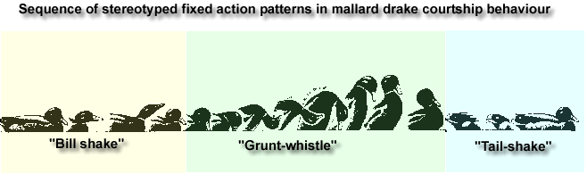During courtship, animals use signals to communicate with mates and members of their own sex. Males carry out actions which acts as a stimulus to the female, who responds with a specific action of her own.

Adaptation and selection

Adaptation is when organisms adjust to suit the changing environment in which they live.

Adaptation increases the long-term reproductive success of a species by helping members survive long enough to breed.

Diversity in organisms arises from changes to its DNA. These changes occur in two ways:

- Changing the quantity or structure of DNA of an organism (mutation).

- Recombining the existing DNA of two individuals (during sexual reproduction).

Mutations

Mutations are changes in DNA that result in different characteristics. They arise in many ways for example, some bases may be added, deleted or replaced during replication. Any differences in the base sequence of a DNA molecule results in a different amino acid sequence being coded for which will lead to a differet polypeptide. This means a different protein which can disrupt the metabolic pathway leading to production of other substances.

Conjugation

This occurs when one bacterial cell transfers DNA to another and takes place as follows:

- One cell produces a thin projection that meets another cell and forms a thin conjugation tube between the 2 cells.

- The donor cell replicates one of its small circular pieces of DNA (plasmid).

- The circular DNA os broken to make it linear before it passes along the tube to the recipient cell.

- Contact between the cells is brief leaving time for only a portion of the donor’s DNA to be transferred.

- The recipient cell acquires new characteristics from the donor cell.

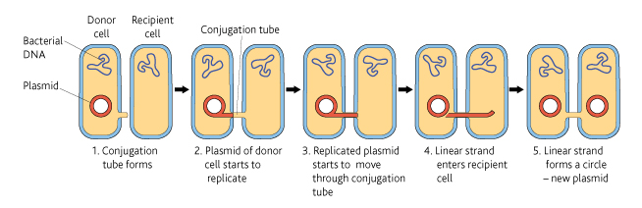

Antibiotics

How antibiotics work

One way they work is to prevent bacteria from making normal cell walls.

In bacterial cells, water constantly enters by osmosis. This entry of water would normally cause the cell to burst- osmotic lysis. It doesn’t burst because of the cell wall that surrounds all of the bacterial cells.

The wall is made of tough material that isn’t easily stretched. As water enters the contents expand and push against the cell wall.

Certain antibiotics kill bacteria by preventing them forming cell walls. They inhibit the synthesis and assembly of the important peptide cross-linkages in the bacterial cell walls. This weakens the walls making them unable to withstand pressure. As a result they are unable to prevent water entering and osmotic lysis occurs.

Antibiotic resistance

Shortly after discovery it became clear that the effectiveness of some antibiotics at killing bacteria was reduced. The populations of bacteria had developed resistance to antibiotics such as penicillin due to chance mutation.

In the case of resistance to penicillin the mutation resulted in certain bacteria being able to make a new protein which broke down the antibiotic penicillin.

The gene for penicillinase and hence antibiotic resistance is passes from one generation to the next by **vertical gene transmission.**

The allele for the resistance is carried on the circular loops of DNA called plasmids. These can be passed from cell to cell by conjugation. Resistance can find its way into other bacterial species by **horizontal gene transmission.**

Horizontal gene transmission can lead to certain bacteria accumulation DNA that gives them resistance to a range of antibiotics.

Antibiotic use and resistance

Antibiotic resistance and tuberculosis

One problem with the antibiotic treatments for TB is the long period for which the antibiotics must be taken.

After a number of months the patients feel better because of the majority of Mycobacterium that has been kills. They then feel tempted to stop taking the antibiotics. This is a problem as the few bacteria that remain are those most resistant to the antibiotic.

There is a selection pressure that leads to the development of strains of Mycobacterium that don’t respond to the antibiotic. These strains interchange genes for resistance by conjugation.

To overcome this problem a ‘cocktail’ of three or four antibiotics is used to ensure at least one will be effective.

Antibiotic resistance and MRSA

Many people carry a bacterium belonging to the genus Staphylococcus in their throats. MRSA is the name given to any strain of this bacterium resistant to one or more antibiotics.

It is especially prevalent in hospitals and can present danger because:

- People in hospital are older, sicker and weaker making them more vulnerable.

- Many people live close together which is perfect for transmission.

-Many antibiotics are used in hospitals and so any mutant resistant strain has an advantage over non-mutant strains.

Implications of antibiotics use

Antibiotic resistance is on the increase for a number of reasons:

- Antibiotics are used to treat minor ailments whose symptoms are trivial/short lived.

- Antibiotics are sometimes used to treat viral diseases; they may help prevent the development of secondary bacterial infections.

- Patients do not always complete the course of antibiotics.

- Patients stockpile unused antibiotics.

- Doctors accept patients’ demands for treatments.

- Antibiotics are used in the treatment of minor ailments in animals.

- They are used to prevent disease among intensively reared animals.

Biodiversity

Biodiversity is the term used to describe variety in the living world. It refers to the number and variety of living organisms in a particular area and has three components:

* **Species diversity:** The number of different species and the number of individuals of each species within one community.
* **Genetic diversity:** The variety of genes possessed by the individuals that make up one species.
* **Ecosystem diversity:** The range of different habitats in a particular area.

One measure of biodiversity is species diversity and has 2 components:

- The number of different species in a given area.

- The proportion of the community that is made up of one species.

Measuring species diversity

One way of measuring species diversity is to use an index calculated as follows:

D= N (N-1)

∑n (n-1)

Where:

d= species diversity index

N= total number of organisms of all species

n= total number of organisms of each species

∑= the sum of

Species diversity and human activities

Impact of agriculture

As natural ecosystems develop them become complex communities with many individuals of a large number of different species. Agricultural ecosystems are controlled by humans.

Farmers select species for particular qualities meaning the number of species, and genetic variety of alleles they possess is reduced. Any particular area can only support a certain amount of biomass.

Impact of deforestation

As forests form layers between the ground and tops of trees there are numerous habitats available. Different species are adapted to living in these habitats and species diversity is high.

The most serious consequence is loss of biodiversity. Up to 50000 species are lost each year.